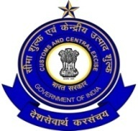
सीमा शुल्क के उपायुक्त के कार्यालय / Office of the
Deputy Commissioner of Customs
पत्तन क्षेत्र / PORT AREA, काकीनाडा सीमा शुल्क सदन /
KAKINADA CUSTOM HOUSE, काकीनाडा/KAKINADA
PHONE: 0884-2357499/ फैक्स : 0884 2365012
Date :06.01.2016
C I R C U L A R / परिपत्र

It is hereby informed that an “Open House Meeting” will be held on 12th January, 2016 will be conducted after the completion of CCFC meeting (scheduled at 10:30 AM),likely to be around 11:00AM.
Further, there will be a meeting of the “TAX PAYER’S SERVICE” as soon as the completion of the Open House Meeting (at about 11:45 AM).

All are requested to attend the meeting and make it a success.

Regards

Sd/-
(M.SREEKANTH)
उपायुक्त/ DEPUTY COMMISSIONER

